 **SPECIMEN **

**Faces in the Clouds: Time-Domain Attribute based access control for cloud-based video content sharing**

**A PROJECT REPORT**

***Submitted by***

**MOHANASREE.P [211417104148]**

**Mahalakshmi.D (2017peccs165)**

**Mahalakshmi.D (2017peccs165)**

**Mahalakshmi.D (2017peccs165)**

**Mahalakshmi.D (2017peccs165)**

**Mahalakshmi.D (2017peccs165)**

**Mahalakshmi.D (2017peccs165)**

**Mahalakshmi.D (2017peccs165)**

**MAHALAKSHMI.D [211417104139]**

#### in partial fulfillment for the award of the degree of

**BACHELOR OF ENGINEERING**

***in***

**COMPUTER SCIENCE AND ENGINEERING**

**PANIMALAR ENGINEERING COLLEGE, CHENNAI 600123.**

**ANNA UNIVERSITY: CHENNAI 600 025**

**AUGUST 2021**

## BONAFIDE CERTIFICATE

Certified that this project report **“Faces in the Clouds: Time-Domain Attribute based access control for cloud-based video content sharing”** is the bonafide work of **“MOHANASREE.P [211417104148], MAHALAKSHI.D [211417104139]’’** who carried out the project work under my supervision.

**SIGNATURE SIGNATURE**

**Dr. S. MURUGAVALLI, M.E., Ph.D., Ms. Maheshwari,**

**HEADOFTHEDEPARTMENT Assistant Professor (Gr-18)**

DEPARTMENT OF CSE, DEPARTMENT OF CSE,

PANIMALAR ENGINEERING COLLEGE, PANIMALAR ENGINEERING NAZARATHPETTAI, COLLEGE, NAZARATHPETTAI,

POONAMALLEE, POONAMALLEE,

CHENNAI-600 123. CHENNAI-600 123.

#### Certifiedthattheabovecandidate(s)was/wereexaminedintheAnnaUniversityProjectViva- Voce Examination held

#### on...........................

**INTERNALEXAMINER EXTERNALEXAMINER**

**ACKNOWLEDGEMENT**

We express our deep gratitude to our respected Secretary and Correspondent  **Dr.P.CHINNADURAI, M.A., Ph.D.** for his kind words and enthusiastic motivation,  which inspired us a lot in completing this project.

 We would like express our heartfelt and sincere thanks to our Directors  **Tmt.C.VIJAYARAJESWARI**, **Dr.C.SAKTHIKUMAR, M.E., Ph.D.,** and **Tmt. SARANYASREE SAKTHIKUMAR B.E.,M.B.A.,** for providing us with the  necessary facilities for completion of this project.

We also express our gratitude to our Principal **Dr.K.MANI, M.E., Ph.D.** for his timely  concern and encouragement provided to us throughout the course.

We thank the HOD of CSE Department, **Dr. S.MURUGAVALLI , M.E.,Ph.D.,** for  the support extended throughout the project.

We would like to thank my **Project Guide Ms. Maheshwari** and all the faculty  members of the Department of CSE for their advice and suggestions for the successful  completion of the project.

**NAME OF THE STUDENTS**

**P. MOHANASREE**

**D. MAHALAKSHMI**

**ABSTRACT**

Media streaming applications have recently attracted a large number of users on the Internet. With the advent of these bandwidth-intensive applications, it is economically inefficient to provide streaming distribution with guaranteed QoS relying only on central resources at a media content provider. Cloud computing offers an elastic infrastructure that media content providers (e.g., Video on Demand (VoD) providers) can use to obtain streaming resources that match the demand. Media content providers are charged for the number of resources allocated (reserved) in the cloud. Most of the existing cloud providers employ a pricing model for the reserved resources that is based on non-linear time-discount tariffs (e.g., Amazon CloudFront and Amazon EC2). Such a pricing scheme offers discount rates depending non-linearly on the period of time during which the resources are reserved in the cloud. In this case, an open problem is to decide on both the right amount of resources reserved in the cloud, and their reservation time such that the financial cost on the media content provider is minimized. We propose a simple - easy to implement - algorithm for resource reservation that maximally exploits discounted rates offered in the tariffs, while ensuring that sufficient resources are reserved in the cloud. Based on the prediction of demand for streaming capacity, our algorithm is carefully designed to reduce the risk of making wrong resource allocation decisions. The results of our numerical evaluations and simulations show that the proposed algorithm significantly reduces the monetary cost of resource allocations in the cloud as compared to other conventional schemes.

**i**

**List of figures: Pg. No.**

Fig 1: ER Diagram 35

Fig 2: Use Case Diagram 35

Fig 3: UML Diagram 36

Fig 4: Architecture diagram of Proposed System 36

Fig 5: Home Page1 37

Fig 6: Home Page2 37

Fig 7: Request to service Provider 38

Fig 8: User Login 38

Fig 9: Videos for user 39

Fig 10: User Profile 39

Fig 11: Data and memory Purchase 40

Fig 12: Video playing 40

Fig 13: Provider Login 41

Fig 14: Provider Home 41

Fig 15: User details 42

Fig 16: Channel Details 42

Fig 17: Create Channel 43

Fig 18: Video Stream 43

Fig 19: Admin Login 44

Fig 20: Details regarding the users to admin 44

**ii**

###### TABLE OF CONTENTS

###### CHAPTER NO. TITLE PAGE NO.

###### 

###### ABSTRACT i

###### LIST OF FIGURES ii

1. **INTRODUCTION**

**1.1. OVERVIEW 1**

**1.2. PROBLEM DEFINITION 2**

1. **LITERATURE SURVEY 3**
2. SYSTEM ANALYSIS

**3.1 EXISTING WORK 6**

**3.2 PROPOSED SYSTEM 6 3.3 TECHNOLOGY STACK**

**3.3.1 H/W SYSTEM CONFIGURATION 7 3.3.2 S/W SYSTEM CONFIGURATION 7**

**4. SYSTEM DESIGN**

**4.1 ER DIAGRAM 8**

**4.2 USE CASE DIAGRAM 8**

**4.3. UML DIAGRAM 9**

**5. SYSTEM ARCHITECHURE**

**5.1 ARCHITECHURE OVERVIEW 10**

**5.2 MODULES DESIGN SPECIFICATIONS 11**

**5.2.1 RESOURCE PROVISIONING 11**

**5.2.2 OVERLOAD AVOIDANCE 11**

**5.2.3 MINIMIZING SKEWNESS 11**

**5.2.4 VM MIGRATIONS 12**

**5.3 PROGRAM DESIGN LANGUAGE 13**

**6. SYSTEM IMPLEMENTATION**

**6.1 CLIENT-SIDE CODING 15**

**6.2 SERVER-SIDE CODING 17**

**6.2.1 ADMIN LOGIN 17**

**6.2.2 LOGIN PROVIDER 18**

**6.2.3 PROVIDER HOME 20**

**6.2.4 VIDEO STREAM 25**

**6.2.5 UPLOAD INFO 28**

**7. SYSTEM TESTING**

**7.1 UNIT TESTING 32**

**7.2 INTREGRATION TESTING 32**

**8. CONCLUSION**

**8.1 CONCLUSION AND FUTURE ENHANCEMENTS 33**

**9. REFERENCES 34**

**10. APPENDICES 35**

**CHAPTER 1**

**INTRODUCTION**

**1.1. OVERVIEW:**

Cloud computing is the delivery of on-demand computing services from applications to storage and processing power typically over the internet and on a pay-as-you-go basis. Rather than owning their own computing infrastructure or data centres, companies can rent access to anything from applications to storage from a cloud service provider. One benefit of using cloud computing services is that firms can avoid the upfront cost and complexity of owning and maintaining their own IT infrastructure, and instead simply pay for what they use, when they use it. In turn, providers of cloud computing services can benefit from significant economies of scale by delivering the same services to a wide range of customers.

Several computing paradigms have remarkably changed the way of “web surfing” experience in the past two decades. Grid, cloud, fog, and edge computing represent the key pillars of this evolution. With incorporation of smart phones and high-speed communications, inter-network access has reached a new level of sophistication. Multiple cloud domains and fog services are currently engaged in providing a required set of data or information to its users or customers. Favourable aggregations of service-oriented aspects are presently acting as the basis of such interventions. Users are indebted towards data storage, analysis, visualization, computation, and persuasion as per the prescribed notions of the cloud, fog or edge vendors. Subsequently, network users are getting heavily dependent on the availability of internet connectivity to persuade for the “opted” jobs.

**1.2. PROBLEM DEFINITION:**

This project studies the problem of resource allocations in the cloud for media streaming applications. We have considered non-linear time-discount tariffs that a cloud provider charges for resources reserved in the cloud.

We develop a resource allocation system that can avoid overload in the system effectively while minimizing the number of servers used.

**CHAPTER 2**

**LITERATURE SURVEY**

[1] Shan-Hsiang Shen, proposed a paper titled “Efficient SVC Multicast Streaming for Video Conferencing With SDN Control”. In this paper they have proposed a novel SVC multicast streaming scheme named adaptive SDN-based SVC multicast (ASCast). Each video layer forms a multicast tree, and they formulate a linear programming problem for the tree construction. To address the problem, we design static and dynamic heuristic algorithms to build multicast trees and maximize overall video quality with limited TCAM space. Moreover, to reduce TCAM space consumption, they carefully consider multicast integer programming address assignment for video layers and forwarding rule installation. Based on our evaluation, ASCast provides a 35% higher video data rate and installs 66% fewer forwarding rules into switches than other SVC video multicast schemes.

[2] Mohammad H. Hajiesmaili, Lok To Mak, Zhi Wang, Chuan Wu, Minghua Chen, and Ahmad Khonsari, published a paper called “Cost-Effective Low-Delay Design for Multi-Party Cloud Video Conferencing”. This paper discusses a joint problem of user-to-agent assignment and transcoding-agent selection. The ultimate objective is to simultaneously minimize the cost of the service provider and the conferencing delay. The problem is combinatorial in nature which belongs to the NP-hard node assignment problems. They leverage the Markov approximation framework and devise an adaptive parallel algorithm that finds a close-to-optimal solution to our problem with a bounded performance guarantee. To evaluate the performance of our solution, they implement a prototype video conferencing system, and carry out trace-driven experiments. In a set of large-scale experiments using PlanetLab traces, our solution decreases the operational cost by 77% and simultaneously yields lower conferencing delay compared to an existing alternative.

[3] Deming Zhai, Xianming Liu, Xiangyang Ji, published a paper titled “Joint Gaze Correction and Face Beautification for Conference Video using Dual Sparsity Prior”. This paper proposes to jointly solve the hole-filling problem and the face beautification problem (subtle modifications of facial components and contour to enhance attractiveness of the rendered face) using dual sparsity prior. Specifically, prior to the start of a video conference session, they first train two dictionaries separately offline using two large datasets: one with general face images, the other with “beautiful” human faces, which means faces with high beauty scores. During the actual conference session, they solve the hole-filling and facial components beautification problems simultaneously by seeking two code vectors—one is sparse in the first dictionary and explains the available DIBR-synthesized pixels, the other is sparse in the second dictionary and matches well with the first vector in terms of feature space distance. This ensures an acceptable level of recognizability of the conference subject, while increases proximity to “beautiful” facial features to improve attractiveness. Experimental results show naturally rendered human faces with noticeably improved attractiveness.

[4] Yuanhuan Zheng, Di Wu, Yihao Ke, Can Yang proposed a paper titled “Online Cloud Transcoding and Distribution for Crowdsourced Live Game Video Streaming”. In this paper, they address the problem of cost-effective adaptive live game video streaming from the perspective of CLGVS service providers. Their purpose is to minimize the operational cost for CLGVS service providers by making live transcoding decisions, bit-rate adaptation decisions and datacenter assignment decisions dynamically. Meanwhile, the proposed algorithm also ensures good-enough service quality for viewers. Due to the diversity of game genres, we also take game genres into account when designing our algorithm. To achieve the above purpose, we formulate the problem into a constrained stochastic optimization problem. By leveraging the Lyapunov optimization framework, we derive the online strategy with provable performance bound. To evaluate the effectiveness of the proposed algorithm, we further conduct a series of trace-driven simulations. The experimental results demonstrate the effectiveness of the algorithm in terms of operational cost and service quality. The proposed algorithm can reduce operational cost by up to 50% while achieving goodenough viewer QoE compared with other alternatives.

[5] Xiangbo Li, Mohsen Amini Salehi, Magdy Bayoumi, proposed a paper titled “Cost-Efficient and Robust On-Demand Video Stream Transcoding Using Heterogeneous Cloud Services”. In this paper they proposed an idea to transcode them in an on-demand (i.e., lazy) manner using cloud computing services. The challenge in utilizing cloud services for on-demand video transcoding, however, is to maintain a robust QoS for viewers and cost-efficiency for streaming service providers. To address this challenge, in this paper, they present the Cloud-based Video Streaming Services (CVS2) architecture. It includes a QoS-aware scheduling component that maps transcoding tasks to the Virtual Machines (VMs) by considering the affinity of the transcoding tasks with the allocated heterogeneous VMs. To maintain robustness in the presence of varying streaming requests, the architecture includes a cost-efficient VM Provisioner component. The component provides a self-configurable cluster of heterogeneous VMs. The cluster is reconfigured dynamically to maintain the maximum affinity with the arriving workload. Simulation results obtained under diverse workload conditions demonstrate that CVS2 architecture can maintain a robust QoS for viewers while reducing the incurred cost of the streaming service provider by up to 85%.

**CHAPTER 3**

**SYSTEM ANALYSIS**

**3.1. EXISTING SYSTEM**

Virtual machine monitors (VMMs) like Xen provide a mechanism for mapping virtual machines (VMs) to physical resources. This mapping is largely hidden from the cloud users. Users with the Amazon EC2 service, for example, do not know where their VM instances run. It is up to the cloud provider to make sure the underlying physical machines (PMs) have sufficient resources to meet their needs. VM live migration technology makes it possible to change the mapping between VMs and PMs While applications are running. The capacity of PMs can also be heterogeneous because multiple generations of hardware coexist in a data centre.

**DISADVANTAGES:**

A policy issue remains as how to decide the mapping adaptively so that the resource demands of VMs are met while the number of PMs used is minimized. This is Challenging When the resource needs of VM’s are heterogeneous due to the diverse set of applications they run and vary with time as the workloads grow and shrink. The two main disadvantages are overload and green computing.

**3.2. PROPOSED SYSTEM**

We have proposed algorithms that optimally determine both the amount of reserved resources in the cloud and their reservation time - based on prediction of future demand for streaming capacity – such that the financial cost on the media content provider is minimized. The proposed algorithms exploit the time discounted rates in the tariffs, while ensuring that sufficient resources are reserved in the cloud without incurring wastage. We have evaluated the performance of our algorithms numerically and using simulations. The results show that our algorithms adjust the trade-off between resources reserved on the cloud and resources allocated on-demand. In future work, we shall perform experimental measurements to characterize the streaming demand in the Internet and develop our own demand forecasting module. We shall also investigate the case of multiple cloud providers and consider the market competition when allocating resources in the clouds.

**ADVANTAGES:**

Structured Meetings with Improved Communications

Reduced Travel Time and Costs

Increased Productivity

**3.3. TECHNOLOGY STACK:**

# 3.3.1. H/W SYSTEM CONFIGURATION:

# Processor          -    Pentium –III

RAM                 -    4 GB

Hard Disk          -   260 GB

Key Board         -   Standard Windows Keyboard

Mouse                -   Two or Three Button Mouse

Monitor              -    SVGA

# 

# 3.3.2. S/W SYSTEM CONFIGURATION:

Operating System             - Windows95/98/2000/XP

Front End                          -   HTML, Java, Jsp

Scripts                               -   JavaScript.

Server-side Script              -   Java Server Pages.

Database                            -   My sql

Database Connectivity       -   JDBC.

**CHAPTER 4**

**SYSTEM DESIGN**

**4.1. ER DIAGRAM:**

An entity relationship diagram (ERD) shows the relationships of entity sets stored in a database. An entity in this context is an object, a component of data. An entity set is a collection of similar entities. These entities can have attributes that define its properties.

By defining the entities, their attributes, and showing the relationships between them, an ER diagram illustrates the logical structure of databases.

ER diagrams are used to sketch out the design of a database.

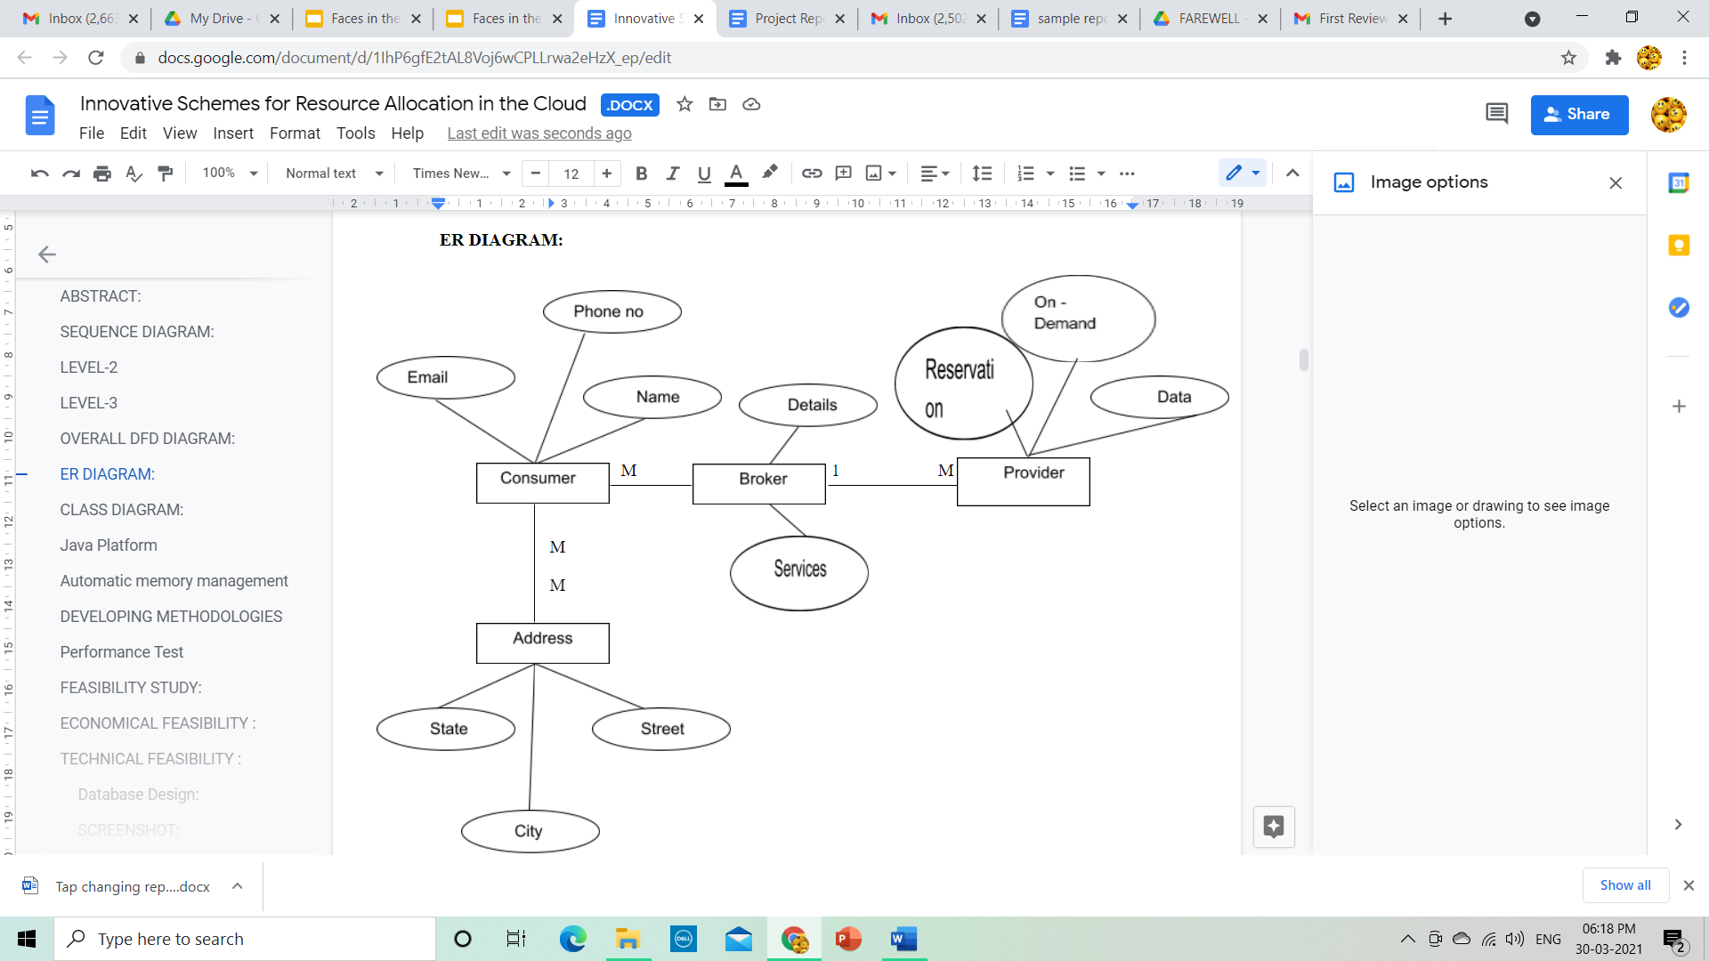

Fig 1: ER Diagram

**4.2. USE CASE DIAGRAM:**

A use case diagram is a graphical depiction of a user's possible interactions with a system. A use case diagram shows various use cases and different types of users the system has and will often be accompanied by other types of diagrams as well. The use cases are represented by either circles or ellipses.

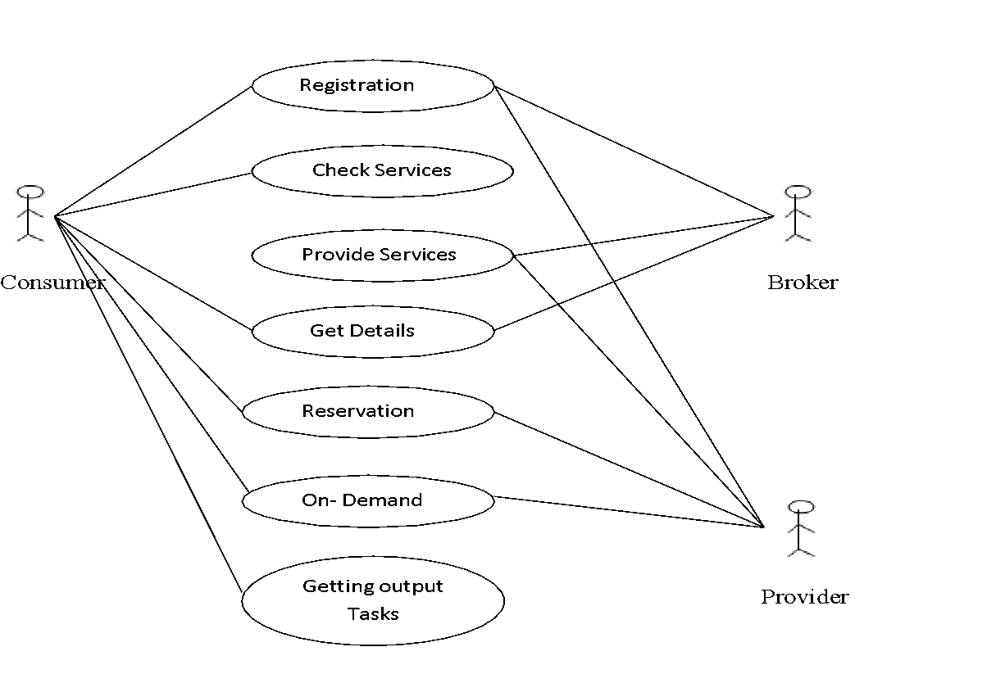

Fig 2: Use Case Diagram

**4.3. UML DIAGRAM:**

The Unified Modeling Language is a general-purpose, developmental, modeling language in the field of software engineering that is intended to provide a standard way to visualize the design of a system.

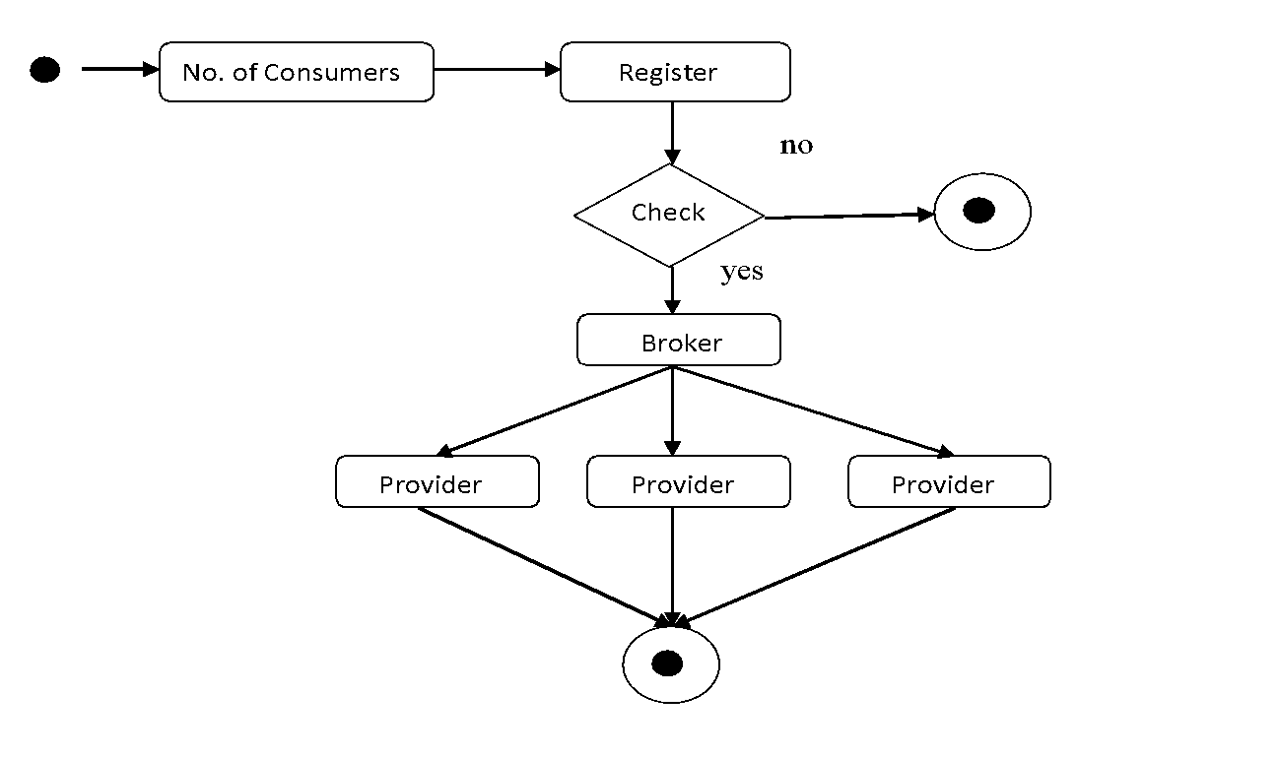

Fig 3: UML Diagram

**CHAPTER 5**

**SYSTEM ARCHITECTURE**

**5.1. ARCHITECTURE OVERVIEW**

We have proposed algorithms that optimally determine whether both the amount of reserved resources in the cloud and their reservation time is based on the prediction of future demand for streaming capacity and the financial cost on the media content provider is minimized. The algorithms are proposed in such a way that it makes use of the discounted time rates in the tariffs, while ensuring that sufficient resources are reserved in the cloud without incurring wastage. The evaluation of the performance of our algorithms is done numerically and also using simulations. Structured meetings with improved communications, reduced travel time and costs and increased productivity are few advantages of the proposed system.

The figure 4 shows the architecture of the proposed work. From the cloud consumer a request signal sent to the cloud broker via virtual machine repository. Then from the cloud broker the signal is passed on to the cloud providers. Now a respond to the request signal is sent back to the consumer from the cloud provider.

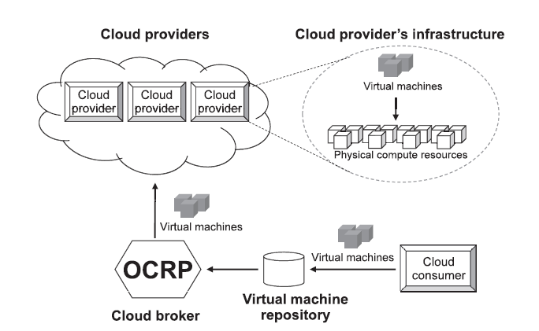

  Fig 4: Architecture diagram of Proposed System

**5.2. MODULES DESIGN SPECIFICATION:**

**5.2.1. Resource Provisioning (RP):**

An optimal cloud resource provisioning is proposed by formulating a stochastic programming model. RP algorithm can provision computing resources for being used in multiple provisioning stages as well as a long-term plan, e.g., four stages in a quarter plan and twelve stages in a yearly plan. The demand and price uncertainty are considered in RP. In particular, an optimal cloud resource provisioning is proposed to minimize the total cost for provisioning resources in a certain time period. To make an optimal decision, the demand uncertainty from cloud consumer side and price uncertainty from cloud providers are taken into account to adjust the trade-off between on-demand and oversubscribed costs.

**5.2.2. Overload avoidance:**

An important issue when operating a load-balanced service is how to handle information that must be kept across the multiple requests in a user's session. If this information is stored locally on one backend server, then subsequent requests going to different backend servers would not be able to find it. This might be cached information that can be recomputed, in which case load-balancing a request to a different backend server just introduces a performance issue.

A variety of scheduling algorithms are used by load balancers to determine which backend server to send a request to. Simple algorithms include random choice or round robin. More sophisticated load balancers may take into account additional factors, such as a server's reported load, recent response times, up/down status (determined by a monitoring poll of some kind), number of active connections, geographic location, capabilities, or how much traffic it has recently been assigned.

**5.2.3. Minimizing skewness:**

Application delivery controllers have evolved from basic server load balancing functional units to fully integrate with cloud workflows and provisioning systems so that they help users enable fast roll-out of new applications to a mobilized work force, improve end-user satisfaction, and reduce the time and cost of application deployment We introduce the concept of skewness to quantify the unevenness in the utilization of multiple resources on a server.

**5.2.4. VM migrations:**

We aim to migrate away the VM that can reduce the server’s Usage the most. In case of ties, we select the VM whose removal can reduce the skewness of the server the most. For each VM in the list, we see if we can find a destination server to accommodate it. The server must not become a hot spot after accepting this VM. Among all such servers, we select one whose skewness can be reduced the most by accepting this VM. Note that this reduction can be negative which means we select the server whose skewness increases the least. If a destination server is found, we record the migration of the VM to that server and update the predicted load of related servers. Otherwise, we move onto the next VM in the list and try to find a destination server for it. As long as we can find a destination server for any of its VMs, we consider this run of the algorithm a success and then move onto the next hot spot. Note that each run of the algorithm migrates away at most one VM from the overloaded server. This does not necessarily eliminate the hot spot, but at least reduces its temperature. If it remains a hot spot in the next decision run, the algorithm will repeat this process. It is possible to design the algorithm so that it can migrate away multiple VMs during each run. But this can add more load on the related servers during a period when they are already overloaded.

**5.3. Program Design Language:**

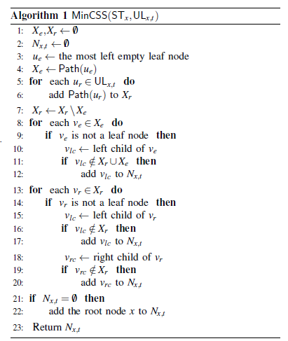

**Algorithm:**

The CP-ABE scheme consists of four operations:

Setup, KeyGen, Encrypt and Decrypt. It is described as follows:

1) (PK;MSK) ← Setup(1). The probabilistic operation takes a security parameter as input and outputs public key PK and master secret key MSK.

2) (SK) ← KeyGen(PK;MSK; S). The operation inputs PK, MSK and a set of attributes S and creates a secret key SK.

3) (CT) ← Encrypt(PK; ck;A). The operation inputs PK, ck = {ck1; : : : ; ckk} and a hierarchical access tree A as shown in the Fig. 2. At last, it creates an integrated

ciphertext of content keys CT.

4) (cki(i ∈ [1; k])) ← Decrypt(PK;CT; SK). The algorithm inputs PK, CT which includes an integrated access structure A, SK described by a set of attributes

S. If the S matches part of A, some content keys cki(i ∈ [1; k]) can be decrypted. If it matches the whole A, all the content keys can be decrypted. Then, the corresponding files mi(i ∈ [1; k]) will be decrypted with the content keys by the symmetric decryption algorithm.

**CHAPTER 6**

**SYSTEM IMPLEMENTATION**

**6.1. CLIENT-SIDE CODING:**

<%@page import="java.sql.*"%>

<%@page contentType="text/html" pageEncoding="UTF-8"%>

<%@page import="java.util.Date"%>

<%@page import="java.text.SimpleDateFormat"%>

<%@page import="java.text.DateFormat"%>

<!DOCTYPE html>

<html>

<head>

<script>

function validateTime()

{

var txt1=document.getElementById("text1").value;

var txt2=document.getElementById("text2").value;

if(txt1==="")

{

    alert("Error: uid cannot be blank!");

    return false;

}

if(txt2==="")

{

    alert("Error: pwd cannot be blank!");

    return false;

}

else{return  true;}

}

</script>

<title>Free Retail Hosting Website Template | Hosting :: w3layouts</title>

<meta http-equiv="Content-Type" content="text/html; charset=utf-8" />

<meta name="viewport" content="width=device-width, initial-scale=1, maximum-scale=1">

<link href="css/style.css" rel="stylesheet" type="text/css" media="all"/>

<link href='http://fonts.googleapis.com/css?family=Electrolize' rel='stylesheet' type='text/css'>

<script type="text/javascript" src="js/jquery.min.js"></script>

<script type="text/javascript">

jQuery(document).ready(function($)

{

$(".scroll").click(function(event)

{

event.preventDefault();

$('html,body').animate({scrollTop:$(this.hash).offset().top},1200);

});

});

</script>

</head>

<body>

<div class="header">

<div class="header_top">

<div style="font-size: 25px;color: white;margin-left: 120px">Innovative Schemes for Resource Allocation

in the Cloud for Media Streaming Applications</div>

<div class="wrap">

<div class="menu">

<ul>

<li class="active"><a href="Admin_Home.jsp">Home</a></li>

<li><a href="Admin_Login.jsp">Logout</a></li>

<div class="clear"></div>

</ul>

</div>

<div class="clear"></div>

</div>

</div>

<div class="main">

<div class="services_heading" style="margin-right: 200px">

<p>Admin Home</p>

</div>

<div class="wrap">

<div class="services">

<div style="margin-left:100px;height: 200px;">

<%Integer hitsCount =

      (Integer)application.getAttribute("hitCounter");

 if(hitsCount<=0)

{

 response.sendRedirect("Home.jsp");

 }

 if(hitsCount<5){

%>

 <div style="font-size: 20px;color: #6fa803;margin-left: 300px">Running From Server-1 </div>

 <div style="font-size: 20px;color: #6fa803;margin-left: 300px">Number Of Users :<%=hitsCount%></div>

<%

}

if(hitsCount>=5 && hitsCount<10)

{

%>

<div style="font-size: 20px;color: #6fa803;margin-left: 300px">Running From Server-2 </div>

<div style="font-size: 20px;color: #6fa803;margin-left: 300px">Number Of Users : <%=hitsCount%></div>

<%

}

if(hitsCount>10){

%>

<div style="font-size: 20px;color:#6fa803;margin-left: 300px">Running From Server-3 </div>

<div style="font-size: 20px;color: #6fa803;margin-left: 300px">Number Of Users : <%=hitsCount%></div>

<%

}

%></div>

</div>

</div>

</div>

<div class="copy_right">

<p>Company Name Â© All rights Reseverd | Design by <a href="http://w3layouts.com"> W3Layouts </a></p>

</div>

</body>

</html>

**6.2. SERVER – SIDE CODING:**

**6.2.1. ADMIN LOGIN:**

<%@page import="java.sql.*"%>

<%@page contentType="text/html" pageEncoding="UTF-8"%>

<%@page import="java.util.Date"%>

<%@page import="java.text.SimpleDateFormat"%>

<%@page import="java.text.DateFormat"%>

<!DOCTYPE html>

<html>

<head>

<script>

function validateTime() {

var txt1=document.getElementById("text1").value;

var txt2=document.getElementById("text2").value;

if(txt1===""){

    alert("Error: uid cannot be blank!");

    return false;

}

if(txt2===""){

    alert("Error: pwd cannot be blank!");

    return false;

}

else{return  true;}

}

</script>

<title>Free Retail Hosting Website Template | Hosting :: w3layouts</title>

<meta http-equiv="Content-Type" content="text/html; charset=utf-8" />

<meta name="viewport" content="width=device-width, initial-scale=1, maximum-scale=1">

<link href="css/style.css" rel="stylesheet" type="text/css" media="all"/>

<link href='http://fonts.googleapis.com/css?family=Electrolize' rel='stylesheet' type='text/css'>

<script type="text/javascript" src="js/jquery.min.js"></script>

<script type="text/javascript">

jQuery(document).ready(function($) {

$(".scroll").click(function(event){

event.preventDefault();

$('html,body').animate({scrollTop:$(this.hash).offset().top},1200);

});

});

</script>

</head>

<body>

<div class="header">

<div class="header_top">

<div style="font-size: 25px;color: white;margin-left: 120px" >Innovative Schemes for Resource Allocation

in the Cloud for Media Streaming Applications</div>

<div class="wrap">

<div class="menu">

<ul>

<li class="active"><a href="index.jsp">Home</a></li>

<li><a href="Login.jsp">Login</a></li>

<li><a href="Register.jsp">Register</a></li>

<li><a href="Login_Provider.jsp">Provider</a></li>

<li><a href="">Contact</a></li>

<div class="clear"></div>

</ul>

</div>

<div class="clear"></div>

</div>

</div>

<div class="main">

<div class="services_heading" style="margin-right: 200px">

<p>Admin Login</p>

</div>

<div class="wrap">

<div class="services">

<div style="margin-left:350px;height: 200px;margin-top: 100px">

<%String msg=request.getParameter("msg");

if(msg!=null)

    {

%>

<blink><font size="4" color="red"><%=msg%></font></blink> <br>

<%} %><br>

<form name="form" action="login_1_1.jsp" method="post" onsubmit="return validateTime();">

<label for="text1" style="color: white">Username: </label> <input id="text1" type="text" name="txt1" value="" /><br /> <br />

<label for="text2" style="color: white">Password &nbsp;     :</label><input id="text2" type="password" name="txt2" value="" />

<br />     <br />

&nbsp;&nbsp;&nbsp;&nbsp;&nbsp;&nbsp;&nbsp;&nbsp;&nbsp <input type="submit" value="Login" />

</form>

</div>

</div>

</div>

</div>

<div class="copy_right">

<p>Company Name Â© All rights Reseverd | Design by  <a href="http://w3layouts.com"> W3Layouts </a></p>

</div>

</body>

</html>

**6.2.2. LOGIN PROVIDER:**

<%@page import="java.sql.*"%>

<%@page contentType="text/html" pageEncoding="UTF-8"%>

<%@page import="java.util.Date"%>

<%@page import="java.text.SimpleDateFormat"%>

<%@page import="java.text.DateFormat"%>

<!DOCTYPE html>

<html>

<head>

<script>

function validateTime() {

var txt1=document.getElementById("text1").value;

var txt2=document.getElementById("text2").value;

if(txt1===""){

    alert("Error: uid cannot be blank!");

    return false;

}

if(txt2===""){

    alert("Error: pwd cannot be blank!");

    return false;

}

else{return  true;}

}

</script>

<title>Free Retail Hosting Website Template | Hosting :: w3layouts</title>

<meta http-equiv="Content-Type" content="text/html; charset=utf-8" />

<meta name="viewport" content="width=device-width, initial-scale=1, maximum-scale=1">

<link href="css/style.css" rel="stylesheet" type="text/css" media="all"/>

<link href='http://fonts.googleapis.com/css?family=Electrolize' rel='stylesheet' type='text/css'>

<script type="text/javascript" src="js/jquery.min.js"></script>

<script type="text/javascript">

jQuery(document).ready(function($) {

$(".scroll").click(function(event){

event.preventDefault();

$('html,body').animate({scrollTop:$(this.hash).offset().top},1200);

});

});

</script>

</head>

<body>

<div class="header">

<div class="header_top">

<div style="font-size: 25px;color: white;margin-left: 120px" >Innovative Schemes for Resource Allocation

in the Cloud for Media Streaming Applications</div>

<div class="wrap">

<div class="menu">

<ul>

<li><a href="index.jsp">Home</a></li>

<li><a href="Login.jsp">Login</a></li>

<li><a href="Register.jsp">Register</a></li>

<li class="active"><a href="Login_Provider.jsp">Provider</a></li>

<li><a href="">Contact</a></li>

<div class="clear"></div>

</ul>

</div>

<div class="clear"></div>

</div>

</div>

<div class="main">

<div class="services_heading" style="margin-right: 200px">

<p>Provider Login</p>

</div>

<div class="wrap">

<div class="services">

<div style="margin-left:350px;height: 200px;margin-top: 100px">

<form name="form" action="login_pro.jsp" method="post" onsubmit="return validateTime();">

<label for="text1" style="color: white">Username: </label> <input id="text1" type="text" name="txt1" value="" /><br /> <br />

<label for="text2" style="color: white">Password &nbsp;     :</label><input id="text2" type="password" name="txt2" value="" />

 <br />     <br />

&nbsp;&nbsp;&nbsp;&nbsp;&nbsp;&nbsp;&nbsp;&nbsp;&nbsp <input type="submit" value="Login" />

</form>

</div>

</div>

</div>

</div>

<div class="copy_right">

<p>Company Name Â© All rights Reseverd | Design by  <a href="http://w3layouts.com"> W3Layouts </a></p>

</div>

</body>

</html>

**6.2.3. PROVIDER HOME:**

<%@page import="java.io.InputStream"%>

<%@page import="java.io.FileInputStream"%>

<%@page import="java.io.File"%>

<%@page import="java.sql.*"%>

<%@page contentType="text/html" pageEncoding="UTF-8"%>

<%@page import="java.util.Date"%>

<%@page import="java.text.SimpleDateFormat"%>

<%@page import="java.text.DateFormat"%>

<!DOCTYPE html>

<html>

<head>

<script>

function validateTime() {

var txt1=document.getElementById("text1").value;

var txt2=document.getElementById("text2").value;

if(txt1===""){

    alert("Error: uid cannot be blank!");

    return false;

}

if(txt2===""){

    alert("Error: pwd cannot be blank!");

return false;

}

else{return  true;}

}

</script>

<title>Free Retail Hosting Website Template | Hosting :: w3layouts</title>

<meta http-equiv="Content-Type" content="text/html; charset=utf-8" />

<meta name="viewport" content="width=device-width, initial-scale=1, maximum-scale=1">

<link href="css/style.css" rel="stylesheet" type="text/css" media="all"/>

<link href='http://fonts.googleapis.com/css?family=Electrolize' rel='stylesheet' type='text/css'>

<script type="text/javascript" src="js/jquery.min.js"></script>

<script type="text/javascript">

jQuery(document).ready(function($) {

$(".scroll").click(function(event){

event.preventDefault();

$('html,body').animate({scrollTop:$(this.hash).offset().top},1200);

});

});

</script>

</head>

<body>

<div class="header">

<div class="header_top">

<div style="font-size: 25px;color: white;margin-left: 120px" >Innovative Schemes for Resource Allocation

in the Cloud for Media Streaming Applications</div>

<div class="wrap">

<div class="menu">

<ul>

<li class="active"><a href="Provider_Home.jsp">Home</a></li>

<li><a href="Provider_Play.jsp">Channel Details</a></li>

<li><a href="Provider_Upload.jsp">Upload Videos</a></li>

<li><a href="Provider_Play_1.jsp">View Stream</a></li>

<li><a href="Logout.jsp">Logout</a></li>

<div class="clear"></div>

</ul>

</div>

<div class="clear"></div>

</div>

</div>

<div class="main">

<div class="services_heading" style="margin-right: 200px">

<p>Provider Home</p>

</div>

<div class="wrap">

<div class="services">

<div style="margin-left: 150px">

<form name="f1">

<%

String st=request.getParameter("s1");

String provider=(String)session.getAttribute("user");

if(provider != null){

if(provider.equals("provider1")){

provider="access";

}

if(provider.equals("provider2")){

provider="server1";

}

if(provider.equals("provider3")){

provider="server2";

}

if(provider.equals("provider4")){

provider="spam";

}}

DateFormat df = new SimpleDateFormat("yy-MM-dd");

String formattedDate = df.format(new Date());

Class.forName("com.mysql.jdbc.Driver");

Connection con = DriverManager.getConnection("jdbc:mysql://localhost:3306/resource","root","admin");

Statement stmt=con.createStatement();

Statement stmt1=con.createStatement();

ResultSet rsx=stmt.executeQuery("select uid from admin where d_provider='"+provider+"'");

%>

<div style="margin-left: 300px">

<h4><font color='white'>Select User</font></h4>

<select name="s1" onChange="document.f1.submit()">

<option>SELECT </option>

<%

  while(rsx.next())

   {

    String x=rsx.getString(1);

   %>

<option <%

   if(st !=null && st.equals(x))

   out.println(x);

      %>

    ><%=x%></option>

<%

   }

   %>

</select><br>

</div>

  <%

     if(st !=null)

       {

            Statement stmt11;

        try {

          Class.forName("com.mysql.jdbc.Driver");

         con = DriverManager.getConnection("jdbc:mysql://localhost:3306/resource","root","admin");

        String qry="select * from admin where uid='"+st+"' and date1>'"+formattedDate+"'";

stmt = con.createStatement();

        ResultSet  rst = stmt.executeQuery(qry);

        if(rst.next())

          {

            String DB=rst.getString("d_provider");

            String tbl=rst.getString("u_tab");

Connection conn = null;

       Statement st2=null;

long filesizeInKB=0;

     String filename=request.getParameter("file");

File file = new File("C:\\Documents and Settings\\vinoth.TN\\Desktop\\"+filename);

           long filesize = file.length();

           filesizeInKB = filesize / 1024;

long tot_db_len= Integer.parseInt(rst.getString("d_size")) ;

 try {

      Class.forName("com.mysql.jdbc.Driver");

         conn = DriverManager.getConnection("jdbc:mysql://localhost:3306/sns","root","admin");

     st2=conn.createStatement();

String sqlQuer="SELECT table_schema , SUM( data_length + index_length) / 1024' Size in KB' FROM information_schema.TABLES where table_schema='"+DB+"' GROUP BY table_schema  ";

     ResultSet rs=st2.executeQuery(sqlQuer);

     if(rs.next()){

long used_db_len=rs.getInt(2);

long db_free_space=tot_db_len-used_db_len;

long tot_tbl_len=Integer.parseInt(rst.getString("u_size"));

Statement stt = null;

try {

             Class.forName("com.mysql.jdbc.Driver");

         conn = DriverManager.getConnection("jdbc:mysql://localhost:3306/sns","root","admin");

        stt = conn.createStatement();

String sqlQuery="SELECT TABLE_NAME,round(((data_length + index_length)/ 1024 ),2) 'Size in MB' FROM information_schema.TABLES WHERE table_schema = '"+DB+"' and   TABLE_NAME='"+tbl+"' ";

        ResultSet rss=stt.executeQuery(sqlQuery);

         while(rss.next()){

long used_tbl_len=rss.getInt(2);

long free=tot_tbl_len-used_tbl_len;

if(db_free_space>filesizeInKB){

if(free>filesizeInKB){

String uid =request.getParameter("uid");

String file1= request.getParameter("file1");

if(file1 != null){

FileInputStream fis = null;

File image = null;

PreparedStatement st5=null;

if(file1 != ""){

image = new File("D:\\Documents and Settings\\vinoth\\Desktop\\"+file1);

fis = new FileInputStream(image);

        }

try{

Class.forName("com.mysql.jdbc.Driver");

  con = DriverManager.getConnection("jdbc:mysql://localhost:3306/access","root","admin");

String tbb=" "+rst.getString("u_tab")+" ";

st5 =con.prepareStatement("insert into "+tbb+" values (?,?)");

st5.setString(1, uid);

if(file1 != "")

    st5.setBinaryStream(2, (InputStream)fis, (int)(image.length()));

else

    st5.setBinaryStream(2, null);

int i =st5.executeUpdate();

response.sendRedirect("user_page.jsp");

 }

catch(Exception e)

        {

  out.println(e);

            }

}

%>

<font color="#669900 ">

<div style="height: 500px;width: 500px; border-style: ridge ;font-style: italic;margin-left: 100px ">

<center>

<pre>  <b>   <div> Domain Name            : <%=rss.getString(1)%></div></b><br></pre>

<pre>  <b>   <div> Domain Size               : <%=tot_tbl_len%> Kb</div></b><br></pre>

<pre>  <b>   <div> Used Space                : <%=rss.getInt(2)%> Kb</div></b><br></pre>

<pre>  <b>   <div> Free space                : <%=free%> Kb</div></b><br></pre>

<pre>  <b>   <div> Total Provider Memory     : <%= tot_db_len%>Kb</div></b><br></pre>

<pre>  <b>   <div> Available Provider Memory : <%=used_db_len%> Kb</div></b><br></pre>

<pre>  <b>    <div> Used Provider Memory      : <%= db_free_space%> Kb</div></b><br></pre>

</center> </div>

</font>

<%

else{

out.println("out of tbl memory");

}}else{

out.println("out of DB memory");

}

}}

 catch (Exception e) {

out.println("Error in Index JSP" + e);

}

}

}

catch (Exception ea) {

                     out.println("Error in Index JSP" + ea);

      }

 }

else{

out.println("<font color='white'>Not a Valid Profile</font>");

        }}

catch (Exception e) {

          e.printStackTrace();

        }

}

%>

</select>

</form>

</div>

</div>

</div>

</div>

<div class="copy_right">

<p>Company Name Â© All rights Reseverd | Design by  <a href="http://w3layouts.com"> W3Layouts </a></p>

</div>

</body>

</html>

**6.2.4. VIDEO STREAM:**

<%@page import="java.sql.*"%>

<%@page contentType="text/html" pageEncoding="UTF-8"%>

<%@page import="java.util.Date"%>

<%@page import="java.text.SimpleDateFormat"%>

<%@page import="java.text.DateFormat"%>

<!DOCTYPE html>

<html>

<head>

<title>Free Retail Hosting Website Template | Hosting :: w3layouts</title>

<meta http-equiv="Content-Type" content="text/html; charset=utf-8" />

<meta name="viewport" content="width=device-width, initial-scale=1, maximum-scale=1">

<link href="css/style.css" rel="stylesheet" type="text/css" media="all"/>

<link href='http://fonts.googleapis.com/css?family=Electrolize' rel='stylesheet' type='text/css'>

<script type="text/javascript" src="js/jquery.min.js"></script>

<script type="text/javascript">

jQuery(document).ready(function($) {

$(".scroll").click(function(event){

event.preventDefault();

$('html,body').animate({scrollTop:$(this.hash).offset().top},1200);

});

});

</script>

</head>

<body>

<div class="header">

<div class="header_top">

<div style="font-size: 25px;color: white;margin-left: 120px" >Innovative Schemes for Resource Allocation

in the Cloud for Media Streaming Applications</div>

<div class="wrap">

<div class="menu">

<ul>

<li class="active"><a href="Play_Video.jsp">Home</a></li>

<li><a href="Profile.jsp">Profile</a></li>

<li><a href="Purchase.jsp">Purchase</a></li>

<li><a href="">Mail</a></li>

li><a href="Logout.jsp">Logout</a></li>

<div class="clear"></div>

</ul>

</div>

<div class="clear"></div>

</div>

</div>

</div>

<%

String Ad_sess=(String)session.getAttribute("username");

String v_name=request.getParameter("name").trim();

String time=request.getParameter("time");

String S_Time=null;

if(Ad_sess.equals("vinoth")){

 try{ Class.forName("com.mysql.jdbc.Driver");

      Connection con= DriverManager.getConnection("jdbc:mysql://localhost:3306/resource","root","admin");

Statement stw =  con.createStatement();

stw.executeUpdate("update video set time='"+time+"' where F_Name='"+v_name+"' ");

 }

catch(Exception w){

              out.println(w);

              }

}

Statement s2;

try {

Class.forName("com.mysql.jdbc.Driver");

Connection con = DriverManager.getConnection("jdbc:mysql://localhost:3306/resource","root","admin");

String qry1="select * FROM VIDEO where F_Name='"+v_name+"'  ";

s2 = con.createStatement();

ResultSet  r = s2.executeQuery(qry1);

if(r.next())

{

S_Time=  r.getString("time");

}}

catch(Exception r){

out.println(r);

}

%>

<div class="main">

<div class="services_heading">

<p> </p>

</div>

<div class="wrap">

<div class="services">

<%

String video=request.getParameter("name");

int Time=0;

Statement s1;

DateFormat df = new SimpleDateFormat("HH:mm:ss");

 String formattedDate = df.format(new Date());

        out.println(formattedDate);

try {

  Class.forName("com.mysql.jdbc.Driver");

         Connection con = DriverManager.getConnection("jdbc:mysql://localhost:3306/resource","root","admin");

String qry1="SELECT (minute (TIMEDIFF('"+formattedDate+"','"+S_Time+"'))*60)+Second (TIMEDIFF('"+formattedDate+"','"+S_Time+"')) AS 't1 - t2', TIMEDIFF(@t2,@t1) AS 't2 - t1'";

s1 = con.createStatement();

ResultSet  rstt = s1.executeQuery(qry1);

if(rstt.next())

{

Time=rstt.getInt(1);

}}

catch(Exception r){

out.println(r);

}

 out.println(Time);

%>

<div style="">

<video width="1024" height="300"   autoplay>

<source src="<%=video%>#t=<%=Time%>" type="video/mp4">

<object data="<%=video%>#t=<%=Time%>" width="320" height="240">

<embed width="320" height="240" src="111.swf">

</object>

</video></div>

</div>

</div>

</div>

<div class="copy_right">

<p>Company Name Â© All rights Reseverd | Design by  <a href="http://w3layouts.com"> W3Layouts </a></p>

</div>

</body>

</html>

**6.2.5. UPLOAD INFO:**

<%@page import="java.net.InetAddress"%>

<!DOCTYPE html PUBLIC "-//W3C//DTD XHTML 1.0 Strict//EN" "http://www.w3.org/TR/xhtml1/DTD/xhtml1-strict.dtd">

<%@ page import="java.util.List" %>

<%@ page import="java.util.Iterator" %>

<%@ page import="java.io.File" %>

<%@ page import="org.apache.commons.fileupload.servlet.ServletFileUpload"%>

<%@ page import="org.apache.commons.fileupload.disk.DiskFileItemFactory"%>

<%@ page import="org.apache.commons.fileupload.*"%>

<%@ page import="java.io.*,java.sql.*,java.util.*,java.text.*,java.text.SimpleDateFormat" %>

<%@ page contentType="text/html;charset=UTF-8" language="java" %>

<%@ page import="java.io.*" %>

<html xmlns="http://www.w3.org/1999/xhtml">

    <head>

        <meta http-equiv="content-type" content="text/html; charset=utf-8" />

        <title>ONLINE DATA ACCESS</title>

        <meta name="keywords" content="" />

        <meta name="description" content="" />

        <link href="styles.css" rel="stylesheet" type="text/css" />

        <script type="text/javascript" src="lib/jquery-1.3.2.min.js"></script>

        <script type="text/javascript" src="lib/jquery.tools.js"></script>

        <script type="text/javascript" src="lib/jquery.custom.js"></script>

        <!-- Pirobox setup and styles -->

        <script type="text/javascript" src="lib/pirobox.js"></script>

        <script type="text/javascript">

            $(document).ready(function() {

                $().piroBox({

                    my_speed: 400, //animation speed

                    bg_alpha: 0.1, //background opacity

                    slideShow : false, // true == slideshow on, false == slideshow off

                    slideSpeed : 4, //slideshow duration in seconds(3 to 6 Recommended)

                    close_all : '.piro_close,.piro_overlay'// add class .piro_overlay(with comma)if you want overlay click close piroBox

                });

            });

        </script>

        <%

            String msg = request.getParameter("username");

            if (msg != null) {

                session.invalidate();

            }

        %>

        <link href="images/style.css" rel="stylesheet" type="text/css" />

        <!-- Pirobox setup and styles end-->

    </head>

    <body>

<div id="main">

<!-- header begins -->

<div id="header">

<div id="buttons">

<a></a><div class="but_razd"></div>

<a href="Options.jsp?username=<%=msg%>" class="but"  title="">Options</a><div class="but_razd"></div>

<a href="Uploadfiles.jsp?username=<%=msg%>" class="but"  title="">Upload Files</a><div class="but_razd"></div>

<a href="Downloadfiles.jsp?username=<%=msg%>" class="but"  title="">Files</a><div class="but_razd"></div>

<a href="Logout.jsp" class="but"  title="">Log Out</a>

</div>

</div>

<!-- header ends -->

<!-- content begins -->

<div class="gallery">

<div class="gallery_bot">

<h1>Our Photo Gallery</h1>

<div class="row">

<div class="box_img2">

<div class="g_size"><a class="pirobox_gal1" title="1st Project Image"><img src="images/upload.png" alt="" /></a></div>

</div>

<div class="box_razd"></div>

<div class="box_img3">  <br/><br/><br/>

<center><table border="2">

<tr><td><h1>FILE UPLOAD</h1></td></tr>

<%

 try {

String saveFile="",l="",ln="",mname="",dob="",celno="";

String sex="",voterno="",email="",bg="",pstreet="",cstreet="",parea="",carea="",pcity="",ccity="";

String ppinno="",cpinno="",pass="",repass="";

int fileidnum=0,downloadcount=0,vc=0;

String contentType = request.getContentType();

// Create a factory for disk-based file items

DiskFileItemFactory factory = new DiskFileItemFactory();

// Set factory constraints

factory.setSizeThreshold(4012);

//factory.setRepository("c:");

// Create a new file upload handler

ServletFileUpload upload = new ServletFileUpload(factory);

// Set overall request size constraint

//upload.setSizeMax(10024);

// Parse the request

List items = null;

try {

     items = upload.parseRequest(request);

            } catch (FileUploadException e) {

    e.printStackTrace();

            }

byte[] data = null;

String fileName = null;

// Process the uploaded items

Iterator iter = items.iterator();

while (iter.hasNext()) {

FileItem item = (FileItem) iter.next();

if (item.isFormField()) {

//processFormField(item);

String name = item.getFieldName();

String value = item.getString();

if (name.equalsIgnoreCase("uid")) {

l = value;

System.out.println("fn" + l);

                    }

else  if (name.equalsIgnoreCase("cat")) {

 ln = value;

System.out.println("fn" + l);

}

else {

    System.out.println("ERROR");

     }

 } else {

      data = item.get();

      fileName = item.getName();

                }

            }

 saveFile = fileName;

String path = request.getSession().getServletContext().getRealPath("/");

String patt=path.replace("\\build", "");

String strPath = patt+"access"+"\\"+saveFile;

File ff = new File(strPath);

FileOutputStream fileOut = new FileOutputStream(ff);

fileOut.write(data, 0, data.length);

fileOut.flush();

fileOut.close();

out.println(saveFile);

System. out.println("Thrid");

%><br><table border="2"><tr><td><b>You have successfully upload the file:</b>&nbsp;

<%out.println(saveFile);%></td></tr></table>

<%

Connection con = null;

PreparedStatement st5 = null;

FileInputStream fis;

InputStream sImage;

try {

File f = new File(strPath);

long length = f.length();

System.out.println("length " + length);

String ip=request.getRemoteAddr();

Class.forName("com.mysql.jdbc.Driver");

con = DriverManager.getConnection("jdbc:mysql://localhost:3306/resource","root","admin");

String queryString = "insert into video values (?,?,?,?,?,?)";

st5 = con.prepareStatement(queryString);

fis = new FileInputStream(f);

st5.setInt(1,0);

st5.setString(2, saveFile);

st5.setString(3, "");

st5.setString(4,"1");

st5.setString(5, ln);

st5.setString(6, (String)session.getAttribute("user"));

int s = st5.executeUpdate();

response.sendRedirect("Provider_Upload.jsp?Video Uploaded Successfully");

}catch(Exception e)           {

       out.println(e);

                }

}

catch (Exception ex) {

           out.println(ex);

     }

%>

</br> </table>

</center></div>

</div>

<div style="height:13px"></div>

<div style="height:10px"></div>

</div>

</div>

</div>

</body>

</html>

**CHAPTER 7**

**SYSTEM TESTING**

**7.1. UNIT TESTING:**

Unit testing involves the design of test cases that validate that the internal program logic is functioning properly, and that program input produces valid outputs. All decision branches and internal code flow should be validated. It is the testing of individual software units of the application .it is done after the completion of an individual unit before integration. This is a structural testing, that relies on knowledge of its construction and is invasive. Unit tests perform basic tests at component level and test a specific business process, application, and/or system configuration. Unit tests ensure that each unique path of a business process performs accurately to the documented specifications and contains clearly defined inputs and expected results.

**7.2. INTEGRATION TESTING:**

Software integration testing is the incremental integration testing of two or more integrated software components on a single platform to produce failures caused by interface defects.

The task of the integration test is to check that components or software applications, e.g., components in a software system or – one step up – software applications at the company level – interact without error.

**CHAPTER 8**

**CONCLUSION**

**8.1. CONCLUSION & FUTURE ENHANCEMENTS:**

In this project considers recreations of a multi-client, cloud assisted worldwide video conferencing framework. We accept a video switch (for example as created by the V connect venture) that   can move between the cloud facilitated areas in a user transparent way. Utilizing sensible interest from genuine world   information, we examined two diverse interest situations (one   in view of gaming the other dependent on instruction). We thought about   situations where video switch areas were chosen statically   what's more, progressively. Our analyses were rushed to decide the postpone experienced by clients because of the decisions of cloud   have area and courses for their video session.

**CHAPTER 9**

**REFERENCES**

[1] Shan-Hsiang Shen, “Efficient SVC Multicast Streaming for Video Conferencing with SDN Control,” [IEEE Transactions on Network and Service Management](https://ieeexplore.ieee.org/xpl/RecentIssue.jsp?punumber=4275028), vol. 16, pp. 403 - 416, June 2019.

[2] E. Coronado, R. Riggio, J. Villalón, and A. Garrido, “Efficient real-time content distribution for multiple multicast groups in SDNbased WLANs,” IEEE Trans. Netw. Service Manag., vol. 15, no. 1, pp. 430–443, Mar. 2018.

# [3] Mohammad H. Hajiesmaili, Lok To Mak, Zhi Wang, Chuan Wu, Minghua Chen, and Ahmad Khonsari, “Cost-Effective Low-Delay Design for Multiparty Cloud Video Conferencing, ” in [IEEE Transactions on Multimedia](https://ieeexplore.ieee.org/xpl/RecentIssue.jsp?punumber=6046), vol: 19, pp. 2760 - 2774, Dec. 2017

[4] A. Bentaleb, A. C. Begen, R. Zimmermann, and S. Harous, “SDNHAS: An SDN-enabled architecture to optimize QoE in HTTP adaptive streaming,” IEEE Trans. Multimedia, vol. 19, no. 10, pp. 2136–2151, Oct. 2017.

[5] S. Y. Shah, B. Szymanski, P. Zerfos, and C. Gibson, “Towards relevancy aware service-oriented systems in wsns,” IEEE Transactions on Service Computing, vol. 8, 2015.

[6] S. Agarwal, M. Kodialam, and T. V. Lakshman, “Traffic engineering in software defined networks,” in Proc. IEEE INFOCOM, 2013, pp. 2211–2219.

[7] I. Papapanagiotou, M. Falkner, and M. Devetsikiotis, “Optimal functionality placement for multiplay service provider architectures,” IEEE Trans. Network and Service Management, vol. 9, no. 3, pp. 359–372, 2012.

[8] D. Roberts, T. Duckworth, C. Moore, R. Wolff, , and J. O’Hare, “Comparing the end to end latency of an immersive collaborative environment and a video conference,” in Proceedings of the IEEE/ACM international Symposium on Distributed Simulation and Real Time Applications, 2009, pp. 89–94.

[9] M. Chen, G. Su, and M. Wu, “Dynamic resource allocation for robust distributed multi-point video conferencing,” IEEE Trans. on Multimedia, vol. 10, no. 5, August 2008.

[10] N. Laoutaris, G. Smaragdakis, K. Oikonomou, I. Stavrakakis, and A. Bestavros, “Distributed placement of service facilities in large-scale networks,” in IEEE INFOCOM, 2007, pp. 2144–2152.

[11] Y. Chu, S. Rao, S. Seshan, and H. Zhang, “End-to-end delay analysis of videoconferencing over packet-switched networks,” IEEE/ACM Transactions on Networking, vol. 8, no. 4, pp. 479–492, 2000.

**APPENDICES**

**A.1. SAMPLE SCREENS:**

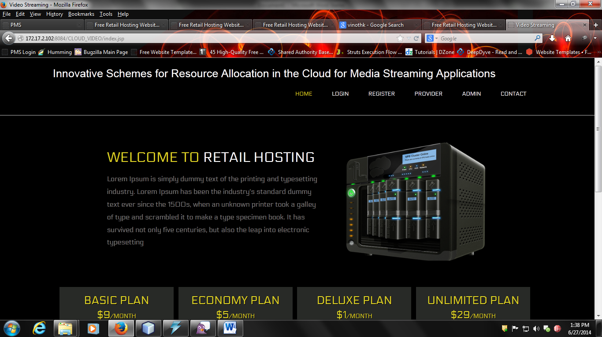

Fig 5: Home Page1

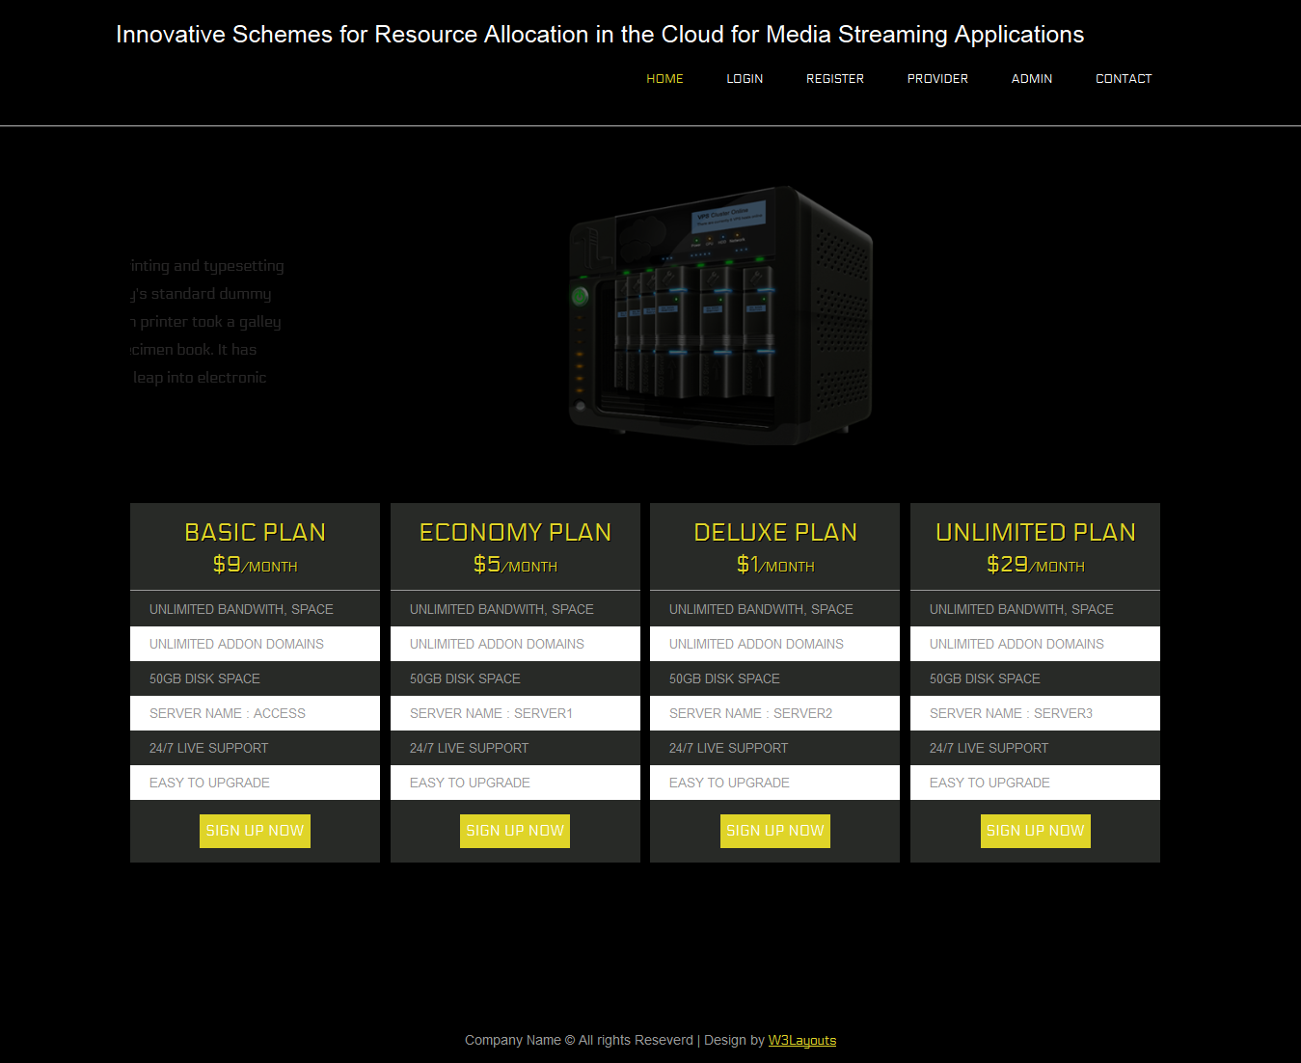

Fig 6: Home Page2

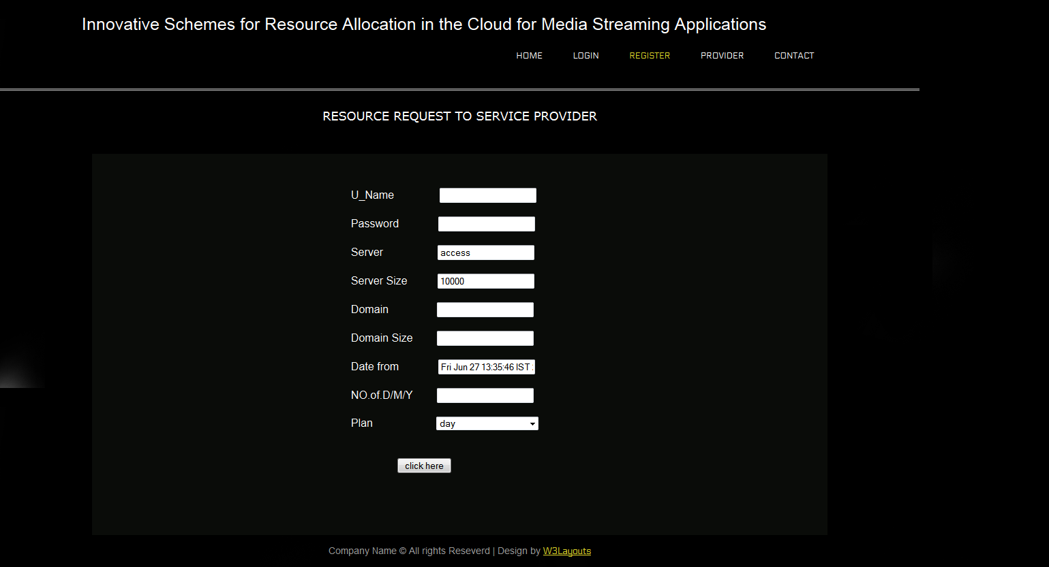

Fig 7: Request to service Provider

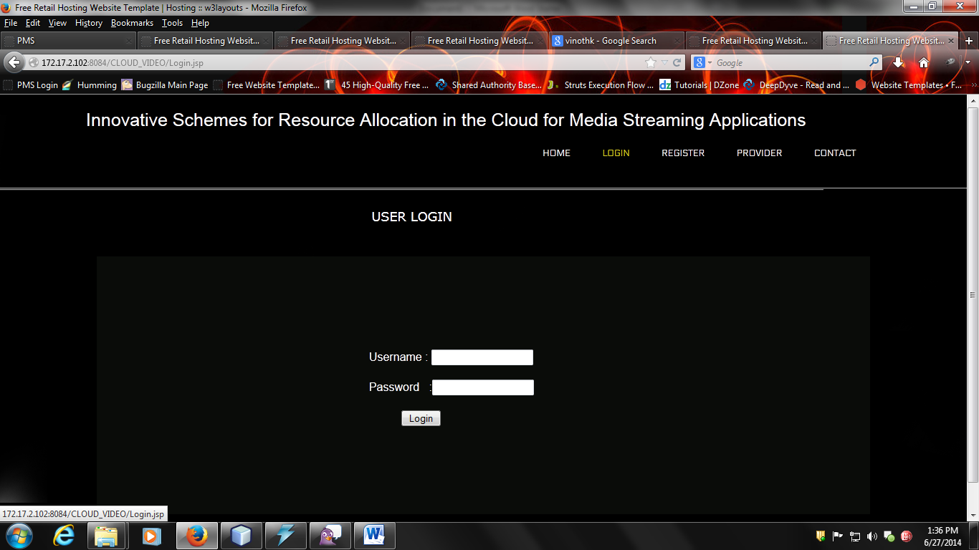

Fig 8: User Login

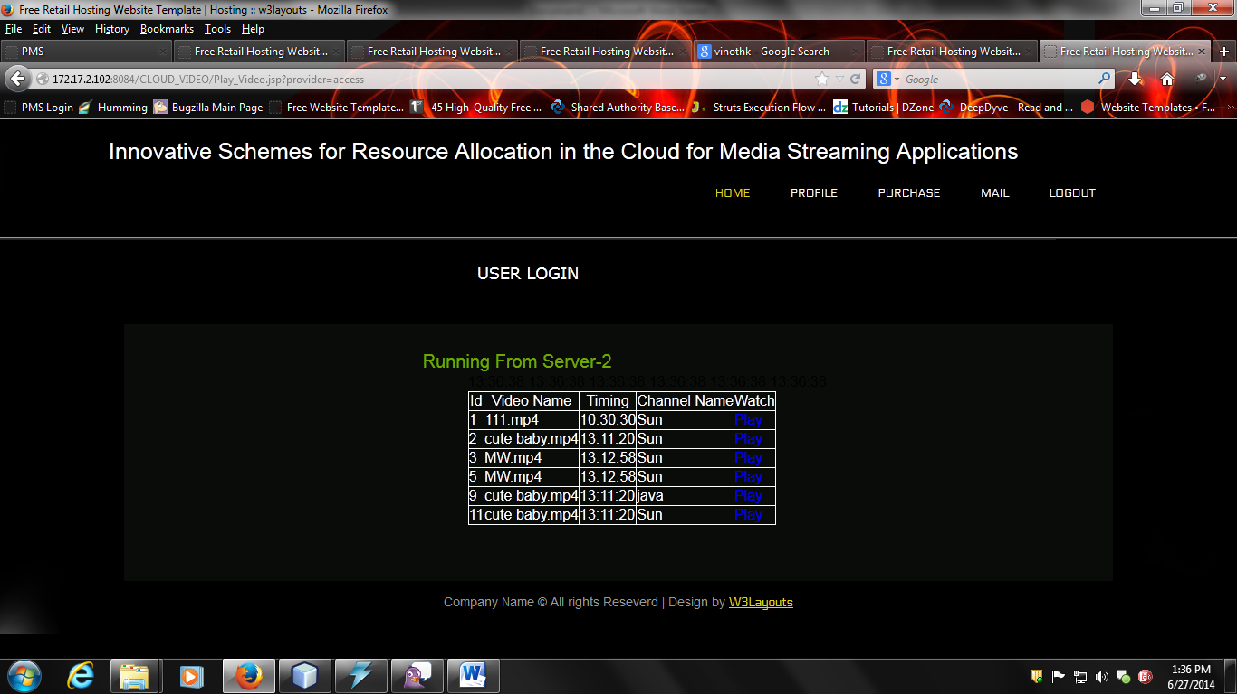

Fig 9: Videos for user

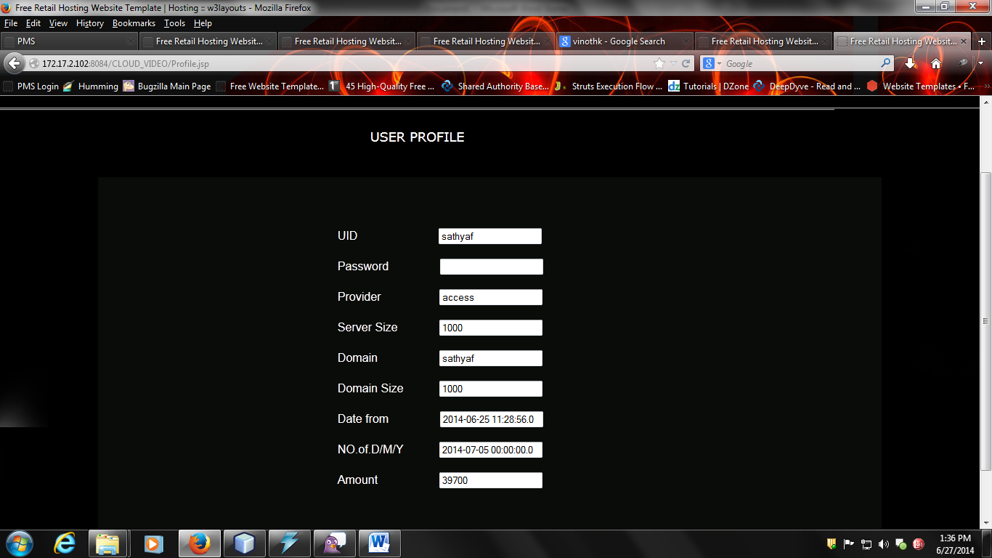

Fig 10: User Profile

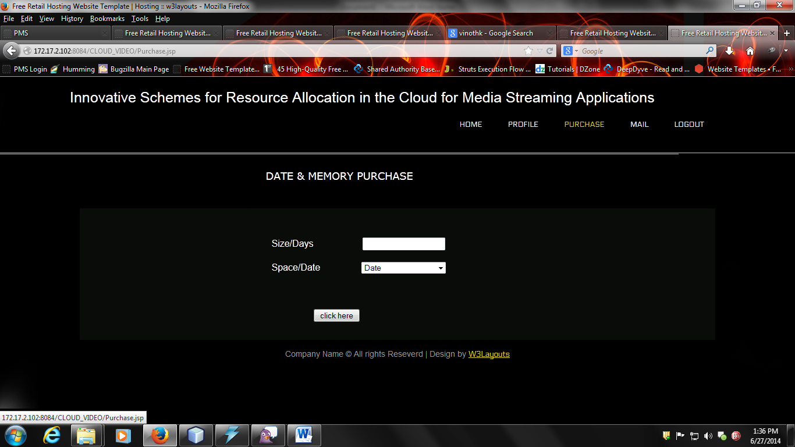

Fig 11: Data and memory Purchase

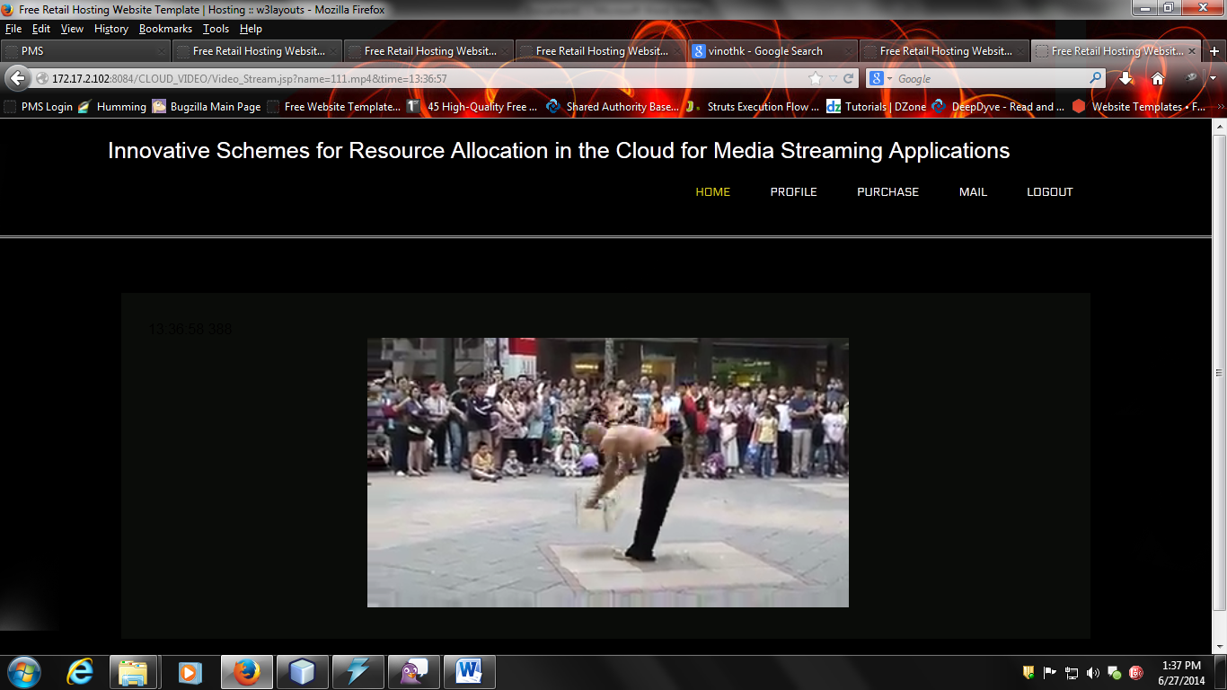

Fig 12: Video playing

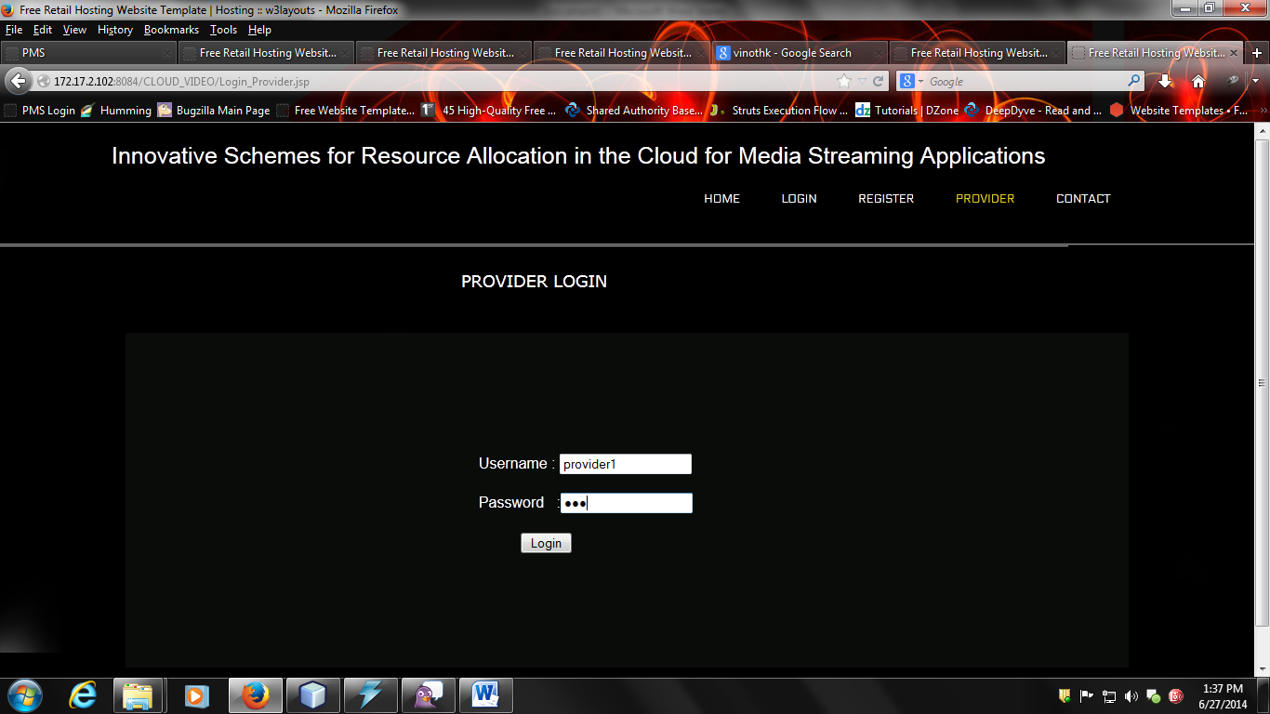

Fig 13: Provider Login

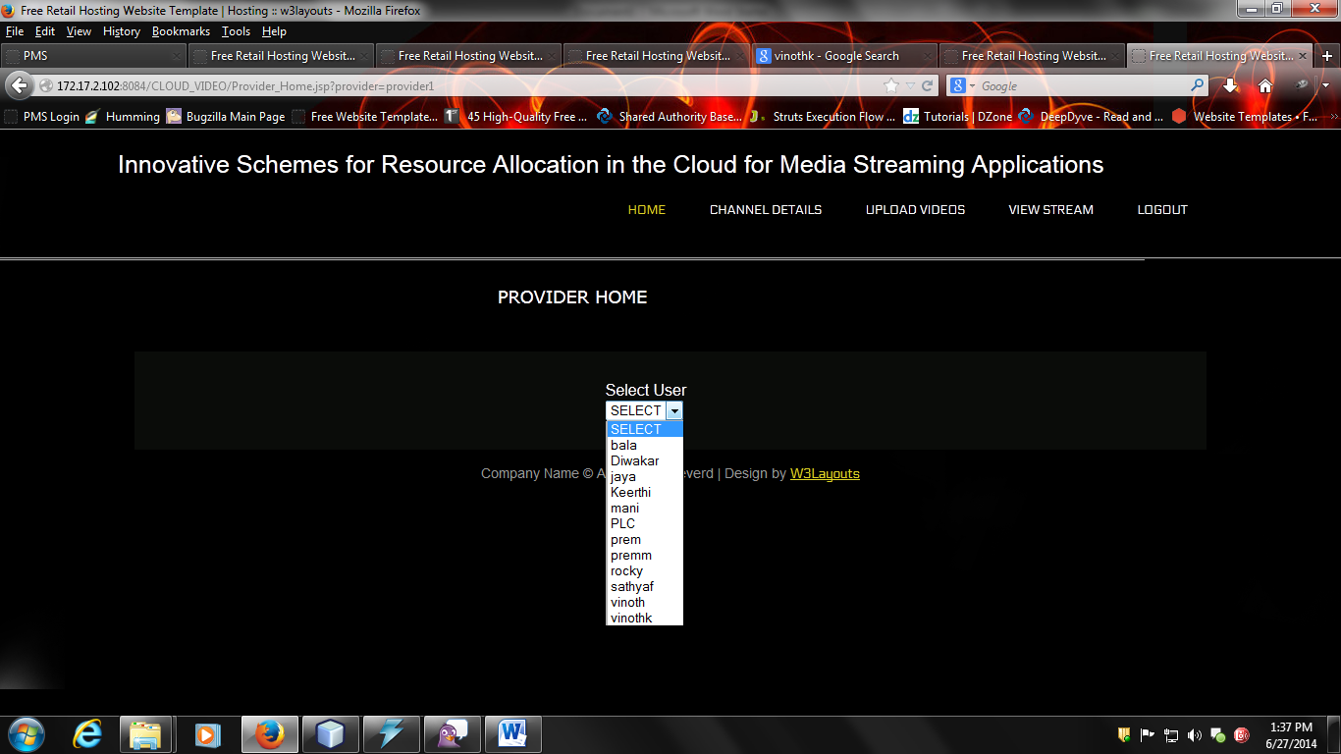

Fig 14: Provider Home

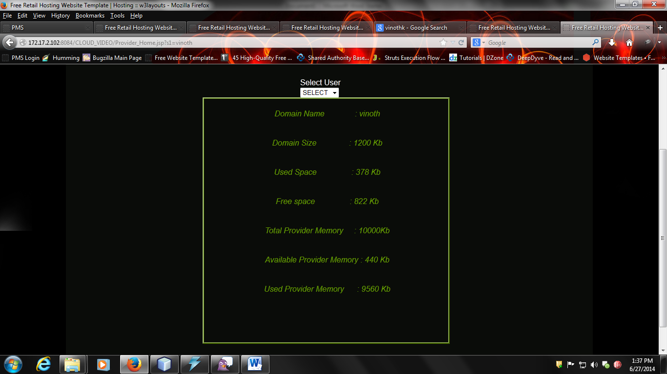

Fig 15: User details

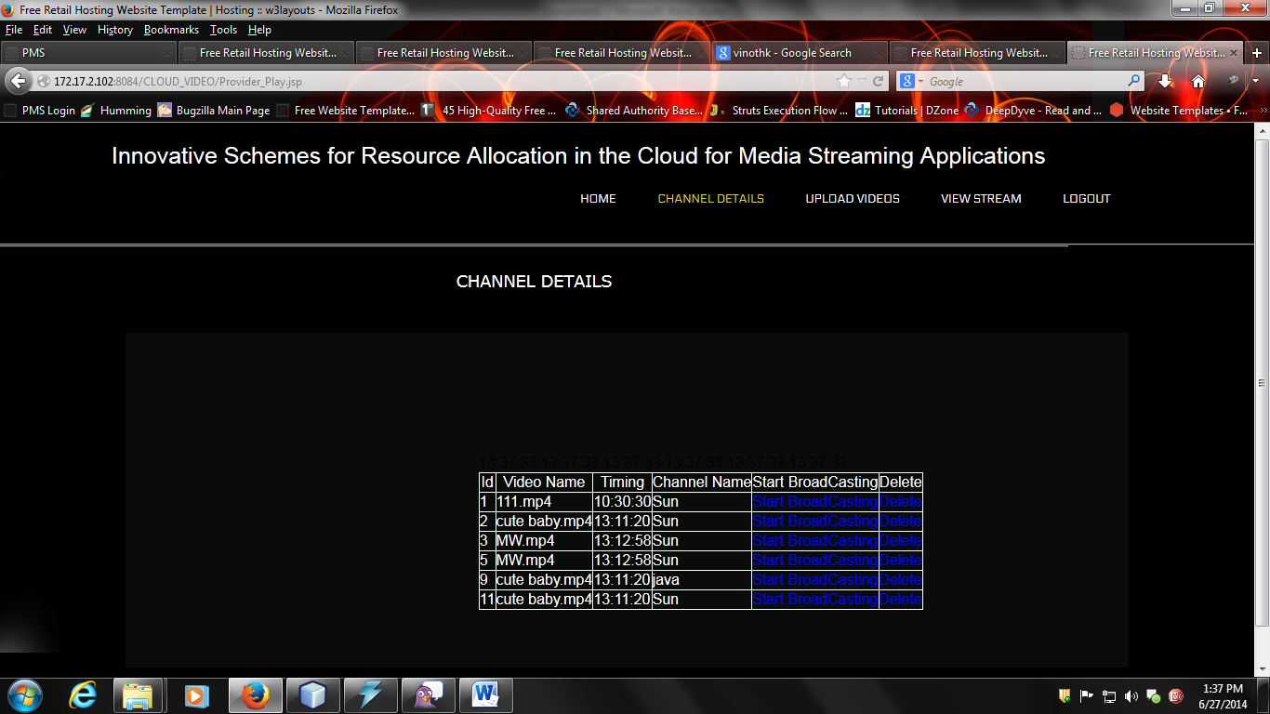

Fig 16: Channel Details

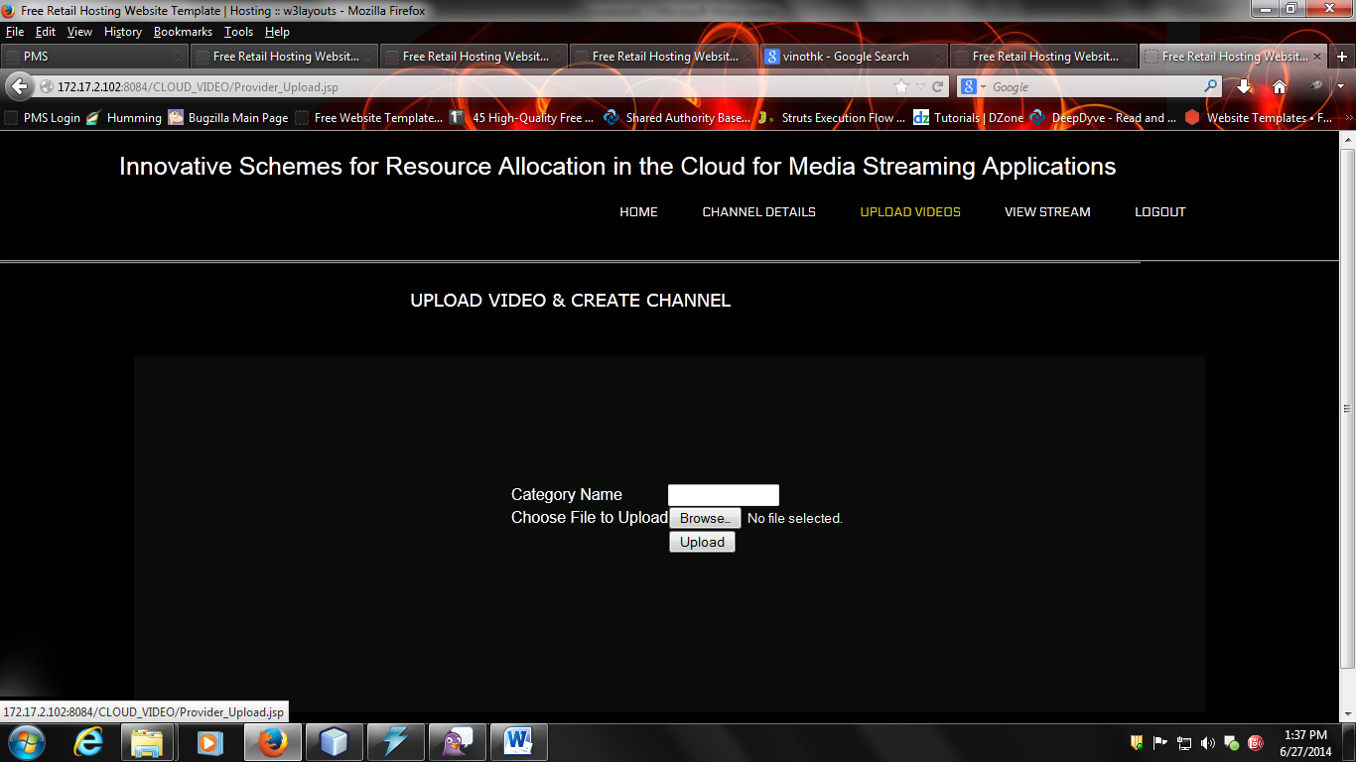

Fig 17: Create Channel

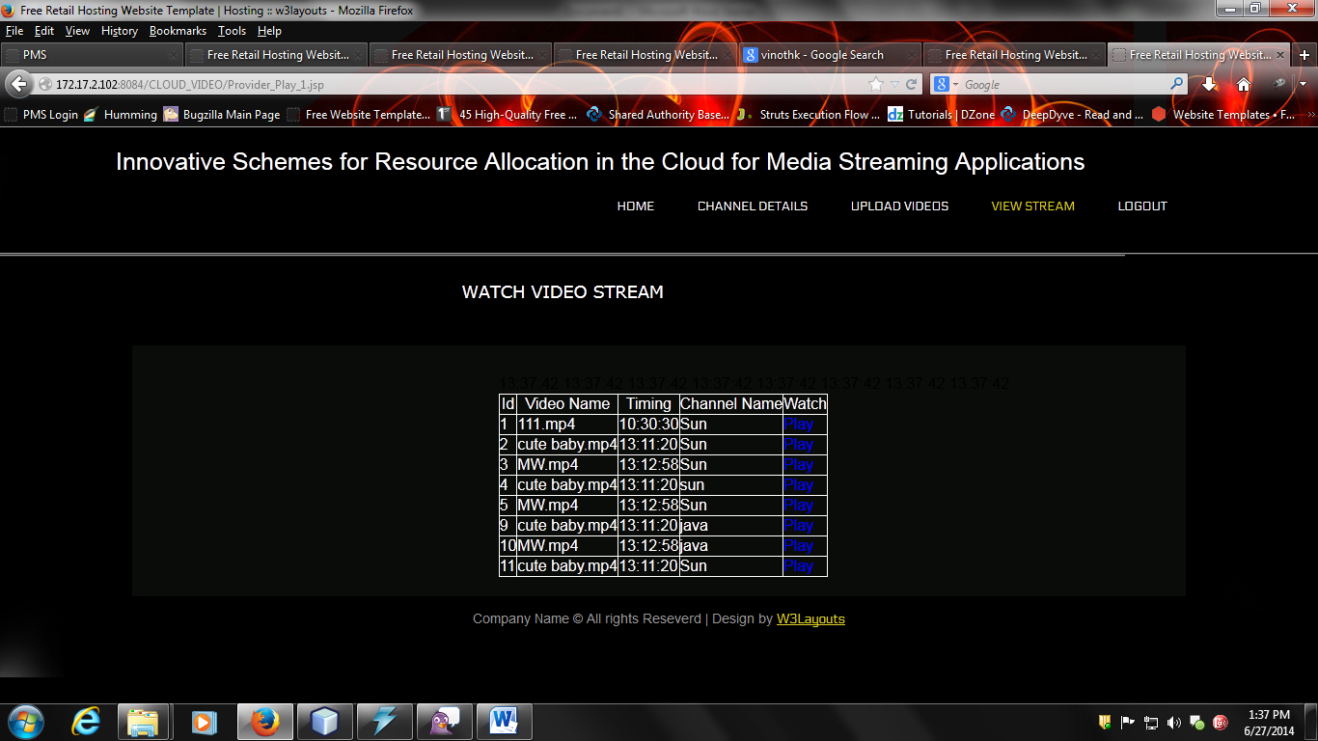

Fig 18: Video Stream

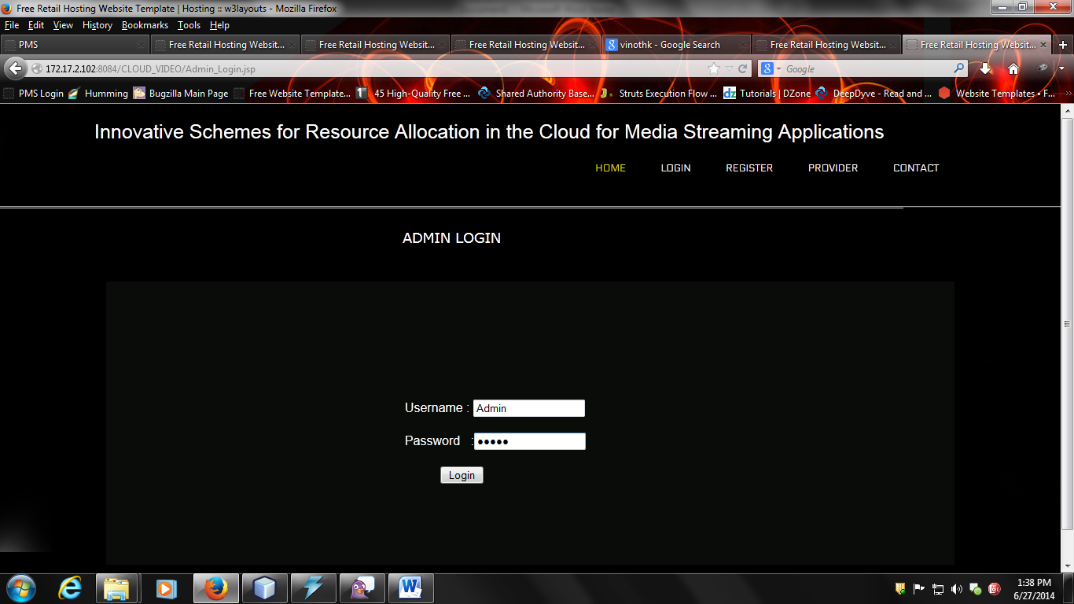

Fig 19: Admin Login

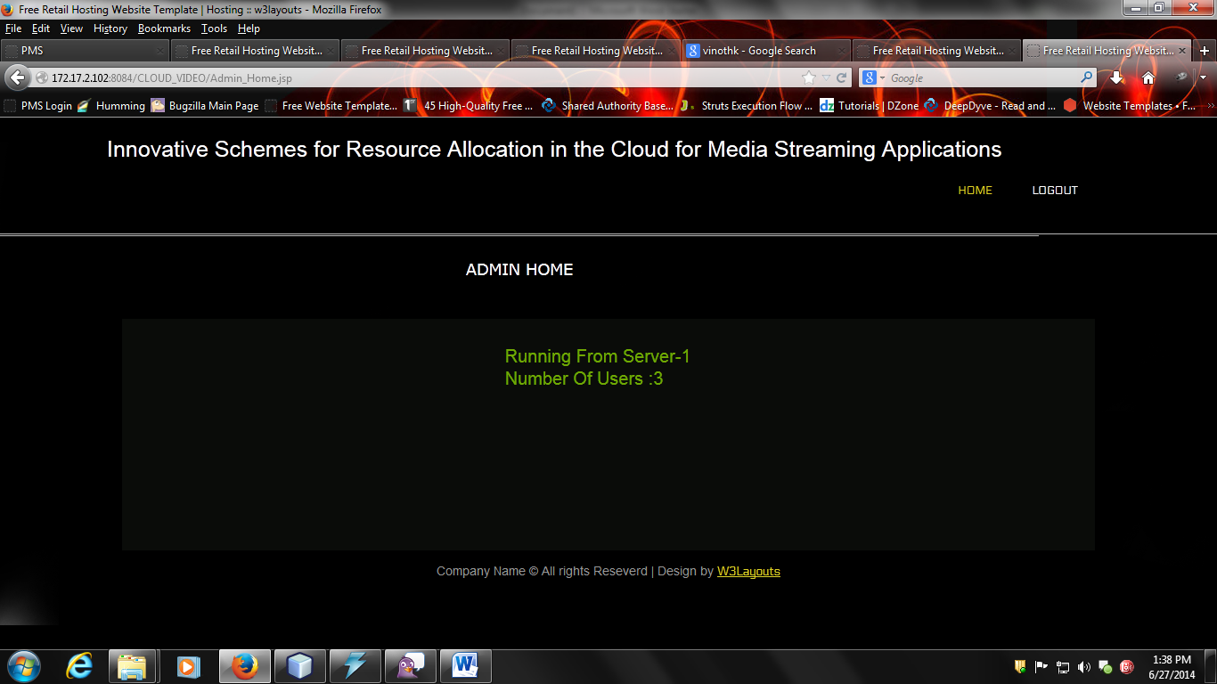

Fig 20: Details regarding the users to admin

**A.2. PUBLICATION:**





